# Starwars Web Portal Manual

The web portal is used for calculating number of required resupplies for each starship. The web portal provides cross platform compatibility with a simple and easy to use fluid UI.

The portal is comprised of a single page allowing users to provide a number representing a distance in Megalights as shown below in [img1].

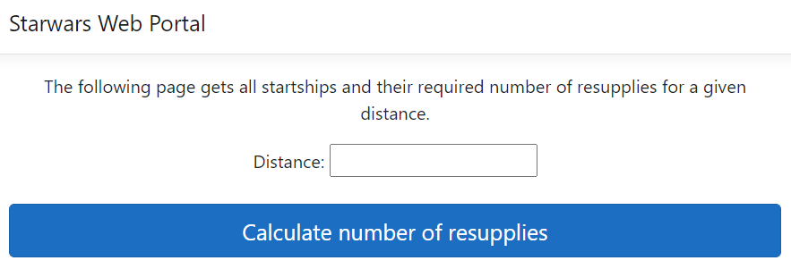

**[img1]**

By providing a distance and clicking the blue button, a grid will be displayed containing all starships and their required resupplies. The grid also users to navigate across different pages in the grid by providing paging arrows below the grid as shown below in [img2].

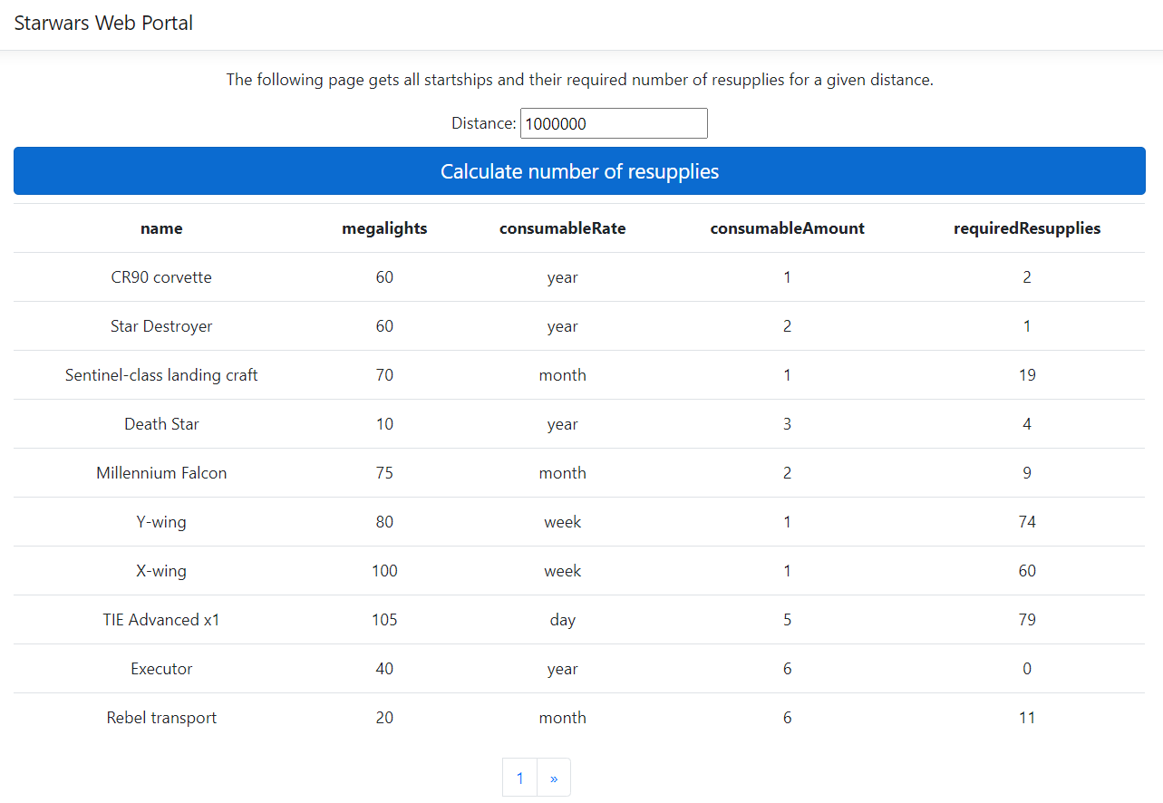

**[img2]**